Project Plan
Core Positioning:
This project focuses on the pain points of garbage collection in community scenarios, aiming to develop an intelligent trolley integrated with intelligent garbage recognition, autonomous obstacle avoidance, and automatic collection capabilities. Through the in-depth integration of mechanical structure, electronic hardware, and software algorithms, it addresses issues such as low efficiency and difficulty in cleaning dead corners in traditional manual garbage collection. It contributes to the environmental governance of smart communities, while reducing labor costs and improving the coverage of community cleaning. Previously designed for agricultural picking, the project has been adjusted to garbage collection based on actual community needs. It strictly adheres to the requirements of the B39VS course and completes the full-cycle project management from planning, design, and development to delivery.
Scope:
Mechanical Design:
Design a lightweight and durable chassis adapted to community road conditions, equipped with an anti-collision structure and a telescopic garbage collection robotic arm compatible with common community garbage types; complete the assembly of mechanical components including chassis, robotic arm and internal mounting brackets to ensure structural stability, and deliver corresponding mechanical drawings and assembled models.
Sensor system:
Configure visual camera modules with sunshade and fill light, ultrasonic obstacle detection sensors, and auxiliary sensors such as power and distance sensors; the sensor system works with the HSV color space model to realize garbage recognition and obstacle detection, ensuring stable data transmission and matching with hardware circuits and software drivers, with corresponding BOM lists and installation diagrams as deliverables.

Software Design:
Build a unified development environment and define standard interfaces between modules; develop motion control code for obstacle avoidance, clamping logic code for the robotic arm, and HSV-based sensor data processing algorithms to realize linkage of garbage recognition, positioning, collection and obstacle avoidance functions, and deliver software architecture documents, control codes, sensor drivers and algorithm test reports.

Web:
Develop a project website to display project overview, technical solutions, team information and progress updates, create promotional posters highlighting core values and key functions of the project, and maintain and update web content in phases to complete the delivery of online accessible websites, high-resolution posters and content update records.
Risk Management:
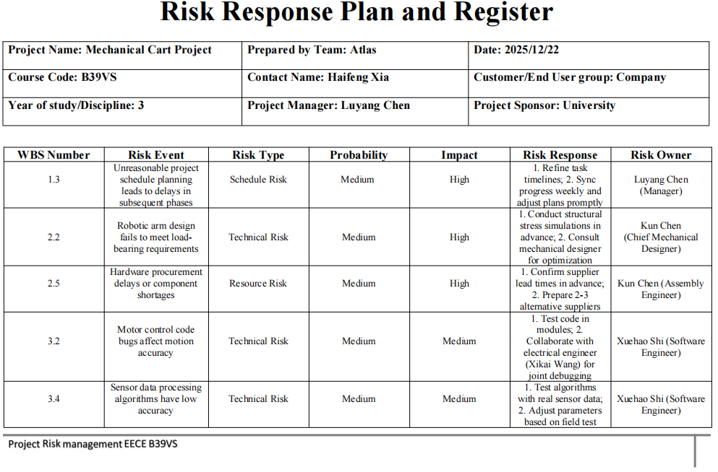
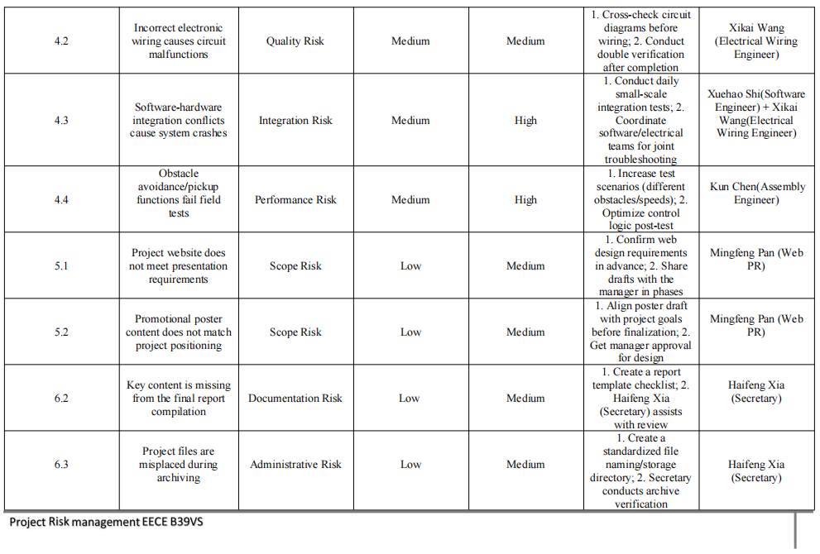

Gantt Chart:
